BECOMING A MEMBER

Membership is open to all, regardless of where you live.
The annual subscription is £20 single, £30 for a couple.

For a membership application form, please contact:

Kensington Gardeners’ Club
12 Linton House
11 Holland Park Avenue
London W11 3RL
Telephone: 020 7727 5235
Email: kensingtongardeners@gmail.com

Or download a form from the website: www.kensingtongardeners.co.uk
and post to the above address.

Alternatively, you can join at any of our meetings.

CONTACT DETAILS

GARDEN VISITS: Fionnuala – 07469 059983

COMPETITION: Nicola – 07949 441662

MEMBERSHIP: Susan – 020 7727 5235

ANYTHING ELSE: Nicola or Fionnuala

Consult our website – www.kensingtongardeners.co.uk – for further information and any changes to the programme.

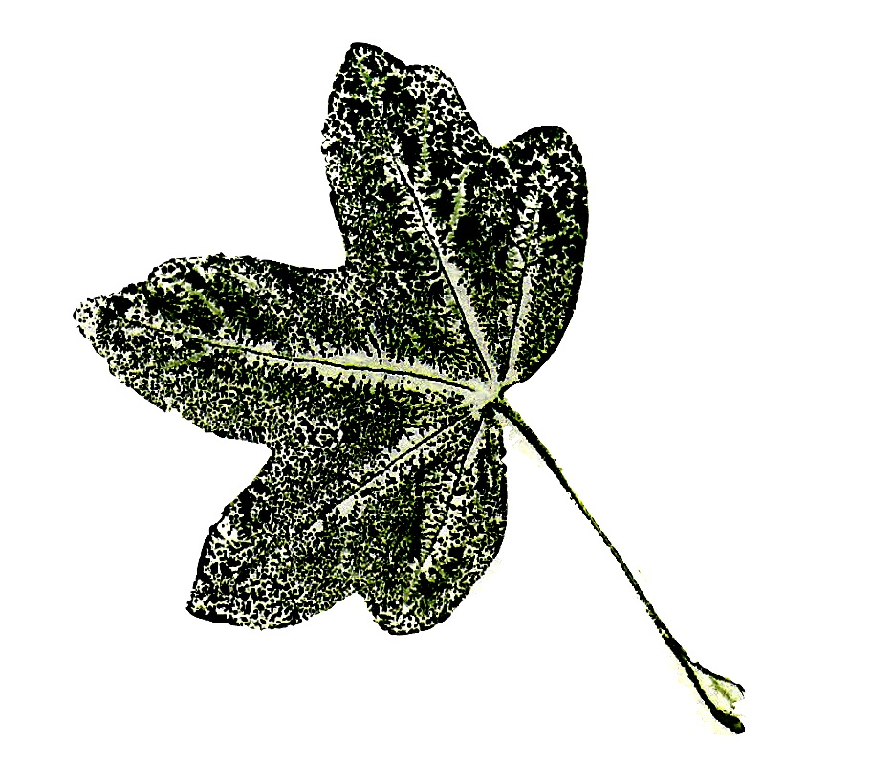

KENSINGTON

GARDENERS’ CLUB

2026 Programme



CLUB MEETINGS take place at St. George’s Church, Aubrey Walk, W8 7JG. Doors open at 2.00 and talks commence at 2.30. Club meetings are free to members and £5 for guests. Afternoon tea follows the meeting – £3.

GARDEN VISITS by coach depart from the bus stand opposite the Czech Embassy, i.e. on the north side of Notting Hill Gate by the 94/148 bus stop. Departure time is 10.00 am unless otherwise noted. Anticipated return time is 6.00 pm. Cost – £50 for members and £55 for guests, to be paid 3 weeks in advance. Coach transport and garden entry fees are included.

GARDEN COMPETITION judging takes place in the summer. Entries are welcome in all categories from window boxes to large gardens. Prizes are presented at the October Club meeting.

A DISCOUNT of 10% is offered by Rassells Garden Centre upon presentation of your club membership card.

EVENTS

Saturday January 17, 2.30
CLUB MEETING – Andy McIndoe, garden author and designer, will show us ‘Beautiful English Gardens’.

Saturday February 14, 2.30
CLUB MEETING – Garden historian Caroline Holmes will present a talk on ‘Impressionists’ Gardens’.

Saturday March 14, 2.30
CLUB MEETING – Christopher Stocks, author and gardener, presents ‘The Book of Garden Flowers’ with beautiful illustrations of his favourite plants.

Saturday April 18, 2.30
CLUB MEETING – Katherine Woods, garden historian, gardener and photographer will speak on ‘The Effect of the Blitz on the Greening of London’.

Wednesday May 13
GARDEN VISIT – Lord Sackville’s private garden at Knole plus Riverhill Himalayan gardens with rhododendrons and azaleas.

Tuesday June 9 – Thursday June 11
GARDEN HOLIDAY to the West Midlands, details to follow.

Saturday June 27, 2.30
CLUB MEETING – Mark Wasilewski LVO, park manager at the Royal Parks, will share his ‘Fifty Years of Horticulture’.

Sunday June 28
COMPETITION JUDGING - Judy Fish will judge this year. See website or telephone Nicola on 07949 441662 to enter.

Wednesday July 15, 6.00 – 7.30
SUMMER PARTY - Join us for drinks and canapes at St. George’s Church.

Sunday July 5 and Sunday July 19, 2.00 – 5.30
GARDEN OPENING – National Garden Scheme
£5 donation. Harvey Groffman – 57 St. Quintin Ave, W10 6NZ

Sunday July 26, 2.30 – 4.00
PRIVATE VIEW FOR MEMBERS – National Garden Scheme £5 donation includes tea and cake. Harvey Groffman –
57 St. Quintin Ave, W10 6NZ

Thursday September 3, 11.00 – 12.00
Private guided tour of Chelsea Physic Garden, limited spaces. £12 per person.

Saturday September 5, 2.30
CLUB MEETING – Roy Barker will present ‘Conquering the Queyras: alpine plants of the southern French Alps’.

Saturday October 3, 2.30
CLUB MEETING – PRIZE GIVING
Meet this year’s winners, accompanied by slides. Q&A with afternoon tea to follow.

Saturday November 14, 2.30
CLUB MEETING – Timothy Walker, botanist, gardener and author, will introduce us to ‘Colour in Garden Design’.

Saturday December 5, 12.30
CLUB MEETING – Enjoy Christmas Lunch with fellow members and a fabulous raffle!

NOTE: Everyone takes part at their own risk. Please be aware all our trips may involve going over uneven surfaces. If you need extra assistance, please arrange this for yourself.

